**Computer Science 120 Recursive Assignment**

1. Write a program to recursively calculate the given Fibonacci number. Example output:

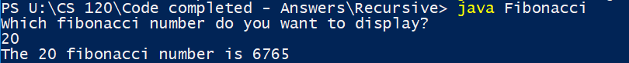

1. Write a program to recursively calculate the given Tribonacci number. Example output:

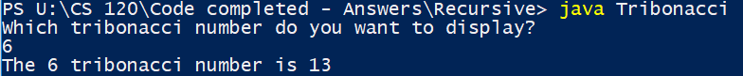

1. 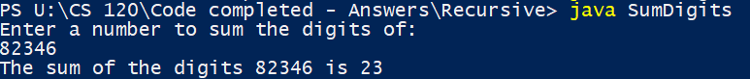Write a program to recursively calculate the sum of the digits in a given integer. Example output: